**FUNCTIONAL ANATOMY AND PHYSIOLOGY**

**Cells of the nervous system**

* The nervous system comprises a complex network of specialised blood vessels, ependymal cells which line the cerebral ventricles, neurons and glial cells, of which there are three types.
* Astrocytes form the structural framework for neurons and control their biochemical environment. Astrocyte foot processes are intimately associated with blood vessels and form the blood-brain barrier.
* Oligodendrocytes are responsible for the formation and maintenance of the myelin sheath, which surrounds axons and is essential for the rapid transmission of action potentials by saltatory conduction.
* Microglial cells are cells of the monocyte/macrophage lineage which play a role in fighting infection and removing damaged cells.
* Peripheral neurons have axons invested in myelin made by Schwann cells.

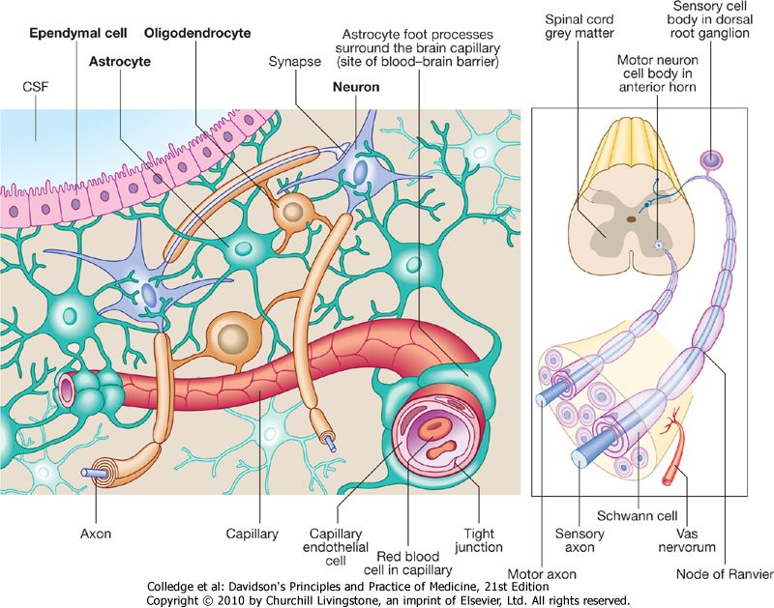

**Generation and transmission of the nervous impulse**

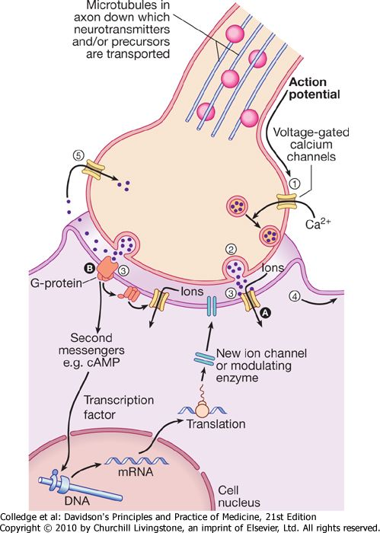

**Neurotransmission and neurotransmitters.**

(1) An action potential arriving at the nerve terminal depolarises the membrane and this opens voltage-gated calcium channels.

(2) Entry of calcium causes the fusion of synaptic vesicles containing neurotransmitters with the pre-synaptic membrane and release of the neurotransmitter across the synaptic cleft.

(3) The neurotransmitter binds to receptors on the postsynaptic membrane to either (A) open ligand-gated ion channels which, by allowing ion entry, depolarise the membrane and initiate an action potential (4), or (B) bind to metabotrophic receptors which activate an effector enzyme (e.g. adenylyl cyclase) and thus modulate gene transcription via the intracellular second messenger system leading to changes in synthesis of ion channels or modulating enzymes.

(5) Neurotransmitters are taken up at the pre-synaptic membrane and/or metabolised.

|  |
| --- |
| Function of the nervous system rests upon two physiological processes:  1. The generation of an action potential and its conduction down axons, and the synaptic transmission of impulses between neurons and muscle cells. These processes depend upon the energy-demanding maintenance of an electrochemical gradient across neuron cell membranes, and alterations in this are effected by specialised ion channels in the membrane. Synaptic transmission involves the release of neurotransmitters. These modulate function of the target cell by interacting with various molecules on the cell surface, including ion channels and other cell surface receptors. At least 20 different neurotransmitters have been identified which act at different sites in the nervous system, and all are potentially amenable to pharmacological manipulation. |

|  |
| --- |
| 2. The neuronal cell bodies are acted upon by synapses with large numbers of other neurons. Each neuron therefore acts as a microprocessor, reacting to the influences upon it by changes to its cell membrane potential, causing it to be more or less able to discharge an impulse down its axon(s). The synapsing neuron terminals are also subject to regulation by receptor sites on their pre-synaptic membrane, which modify the release of transmitter across the synaptic cleft. The effect of some neurotransmitters is to produce long-term modulation of metabolic function or gene expression rather than simply to change the membrane potential. This effect probably underlies more complex processes in cognition, such as long-term memory. |

|  |
| --- |
| **Functional anatomy of the nervous system** |

|  |
| --- |
| Major components of the nervous system and their inter-relationships are depicted in Figure below. |

|  |
| --- |
| **Cerebral hemispheres** |

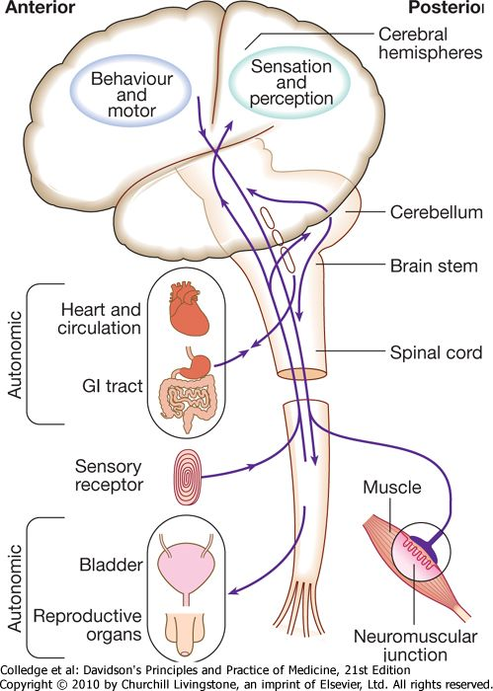

|  |
| --- |
| **Cortical lobar functions** |

|  |  |  |  |  |
| --- | --- | --- | --- | --- |
|  |  | **Effects of damage** | | |
| **Lobe** | **Function** | **Cognitive/behavioural** | **Associated physical signs** | **Positive phenomena** |
| **Frontal** | Personality Emotional control Social behaviour Contralateral motor control Language Micturition | Disinhibition Lack of initiation Antisocial behaviour Impaired memory Expressive dysphasia Incontinence | Impaired smell Contralateral hemiparesis Frontal release signs1 | Versive seizures Focal motor seizures (Jacksonian march) Continuous partial seizures (epilepsia partialis continua) |
| **Parietal: dominant** | Language Calculation | Dysphasia Dyscalculia Dyslexia Apraxia4 Agnosia5 | Contralateral hemisensory loss Astereognosis2 Agraphaesthesia3 Contralateral homonymous lower quadrantanopia Asymmetry of optokinetic nystagmus (OKN) | Focal sensory seizures |
| **Parietal: non-dominant** | Spatial orientation Constructional skills | Neglect of contralateral side Spatial disorientation Constructional apraxia Dressing apraxia | Contralateral hemisensory loss Astereognosis Agraphaesthesia Contralateral homonymous lower quadrantanopia Asymmetry of OKN | Focal sensory seizures |
| **Temporal: dominant** | Auditory perception Language Verbal memory Smell Balance | Receptive aphasia Dyslexia Impaired verbal memory | Contralateral homonymous lower quadrantanopia | Complex hallucinations (smell, sound, vision, memory) |
| **Temporal: non-dominant** | Auditory perception Melody/pitch perception Non-verbal memory Smell Balance | Impaired non-verbal memory Impaired musical skills (tonal perception) | Contralateral homonymous upper quadrantanopia | Complex hallucinations (smell, sound, vision, memory) |
| **Occipital** | Visual processing | Visual inattention Visual loss Visual agnosia | Homonymous hemianopia (macular sparing) | Simple visual hallucinations (e.g. phosphenes, zigzag lines) |
|  |  |  |  |  |

|  |  |
| --- | --- |
| |  | | --- | | 1 Grasp reflex, palmomental response, rooting reflex. 4 Inability to perform complex movements in the presence of normal motor, sensory and cerebellar function. 5 Inability to recognise or discriminate. 2 Inability to determine 3-D shape by touch. 3 Inability to 'read' numbers or letters drawn on hand, with eyes shut. |  * The cerebral hemispheres coordinate the highest level of nervous function, the anterior half dealing with executive ('doing') functions and the posterior half constructing a perception of the environment ('receiving and perceiving'). * Each cerebral hemisphere has four functionally specialised lobes. * Many of the functions are lateralised and this depends on which of the two hemispheres is 'dominant', i.e. the one in which language function is represented. * In right-handed individuals the left hemisphere is almost always dominant, while in left-handers either hemisphere may be dominant with about equal frequency. |

|  |
| --- |
| * The frontal lobes are concerned with executive function, movement and behaviour. * In addition to the primary and supplementary motor cortex, there are specialised areas for the control of eye movements, speech (Broca's area) and micturition. |

|  |
| --- |
| * The parietal lobes are concerned with the integration of sensory perception. * The primary sensory cortex lies in the post-central gyrus of the parietal lobe. * Much of the remainder is devoted to 'association' cortex, which integrates the input from the various sensory modalities. * The supramarginal and angular gyri of the dominant parietal lobe form part of the language area. Close to these are regions dealing with numerical function. * The non-dominant parietal lobe houses areas concerned with spatial awareness and orientation. |

|  |
| --- |
| * The temporal lobes contain the primary auditory cortex and primary vestibular cortex. * On the medial side lie the olfactory cortex and the parahippocampal cortex which is involved in memory function. * The temporal lobes also contain many structures associated with the limbic system, including the hippocampus and the amygdala, which are involved in the processing of memory and emotions. * The dominant temporal lobe also participates in language functions, particularly verbal comprehension (Wernicke's area). * Music processing occurs in both temporal lobes, rhythm being processed on the dominant side and melody/pitch more on the non-dominant side. |

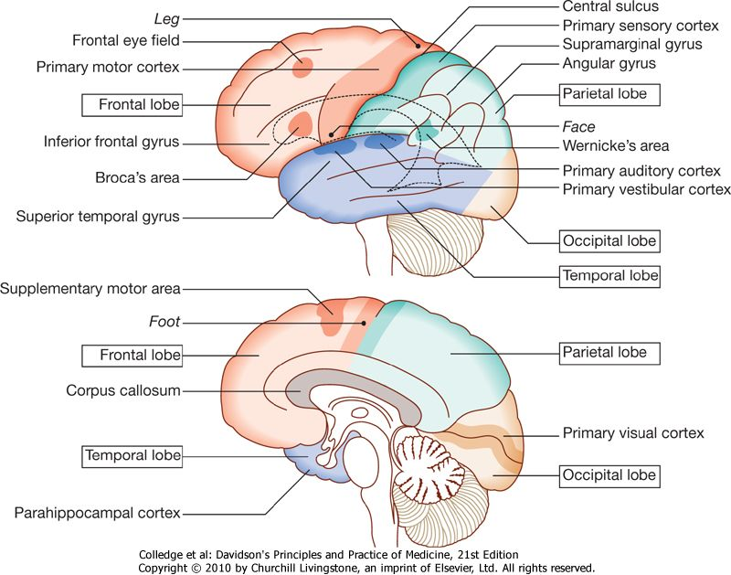

|  |
| --- |
| * The occipital lobes are principally concerned with visual processing. * The contralateral visual hemifield is represented in the primary visual (striate) cortex, and areas immediately surrounding this are involved in the processing of specific visual submodalities such as colour, movement or depth, and the analysis of more complex visual patterns such as faces. |

|  |
| --- |
| * Collections of cells in the depths of the hemispheres deal with motor control (the basal ganglia), the appropriate attention to sensory perception (the thalamus), emotion and memory (the limbic system), and internal bodily functions such as temperature and appetite control (the hypothalamus). * The cerebral ventricles contain the choroid plexus and this produces the cerebrospinal fluid (CSF), which cushions the brain within the cranium. * The CSF flows through the third and fourth ventricles and exits the brain through foramina in the brain stem to circulate down and around the spinal cord and over the brain surface where it is reabsorbed into the cerebral venous system. |
| **The brain stem** | |

|  |
| --- |
| * In addition to containing all the sensory and motor pathways entering and leaving the hemispheres, the brain stem houses the nuclei of the cranial nerves and nuclei projecting to the cerebrum and cerebellum, as well as other important collections of neurons in the reticular formation. * The cranial nerve nuclei provide motor control to muscles of the head (including the face and eyes) and some in the neck, along with coordinating sensory input from the special sense organs and the face, nose, mouth, larynx and pharynx. * They also control autonomic functions including pupillary, salivary and lacrimal functions. * The reticular formation is predominantly involved in the control of conjugate eye movements, the maintenance of balance, cardiorespiratory control and the maintenance of arousal. |

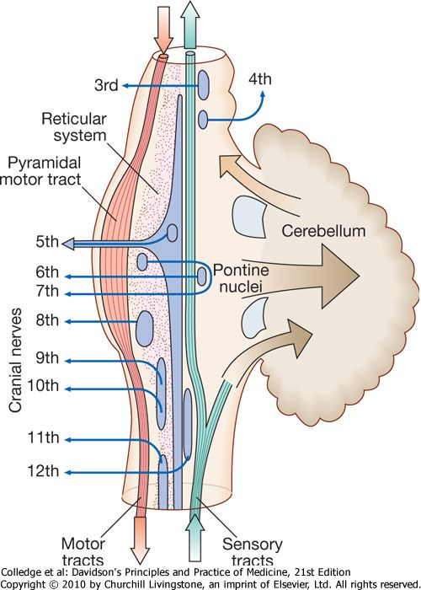

|  |
| --- |
| **The spinal cord** |

|  |
| --- |
| * The spinal cord contains not only the **afferent** and **efferent** fibres arranged in functionally discrete bundles but also, in the **grey** matter, collections of cells which are responsible for lower-order motor reflexes and the primary processing of sensory information, including pain. |

|  |
| --- |
| **The peripheral nervous system** |

|  |
| --- |
| * The sensory cell bodies of peripheral nerves are situated in the dorsal root ganglia in the spinal exit foramina, whilst the distal ends of their neurons are invested with various specialised endings for the transduction of external stimuli into nervous impulses. * The motor cell bodies are in the anterior horns of the spinal cord. * Motor neurons initiate muscle contraction by the release of acetylcholine across the neuromuscular junction, which results in change in potential in the muscle end plate. * To increase the speed of impulse conduction, peripheral nerve axons are variably invested in myelin sheaths consisting of the wrapped membranes of Schwann cells. * Thus, any peripheral nerve is made up of a combination of large, fast, myelinated axons (which carry information about joint position sense and commands to muscles) and smaller, slower, unmyelinated axons (which carry information about pain and temperature, as well as autonomic function). |

|  |
| --- |
| **The autonomic system** |

|  |
| --- |
| * The autonomic system plays a key role in regulating the cardiovascular and respiratory systems, the smooth muscle of the gastrointestinal tract, and many exocrine and endocrine glands throughout the body. * The autonomic system is controlled centrally by diffuse modulatory systems in the brain stem, limbic system and frontal lobes, which are concerned with arousal and background behavioural responses to threat. * The output of the autonomic system is divided functionally and pharmacologically into two divisions: the parasympathetic and sympathetic systems. |
| * Movement of a body part necessitates changes in posture and alteration in the tone of many muscles, some quite distant from the part being moved.   **MOTOR SYSTEM**   * The motor system consists of a hierarchy of control mechanisms that maintain body posture and baseline muscle tone upon which a specific movement is superimposed. * The lowest order of this hierarchy resides in the grey matter of the spinal cord which controls the muscle tone response to stretch, and the reflex withdrawal response to noxious stimuli. * The afferent side of the stretch reflex is detected by muscle spindles that sense lengthening of the muscle and initiate a monosynaptic reflex leading to muscle contraction. * The predominantly inhibitory descending input from the brain stem and cerebral hemispheres modulates the sensitivity of the stretch reflex. * It is the state of this **stretch reflex that is tested clinically when a patient's tendon reflexes are elicited and muscle tone is assessed**. * Polysynaptic connections in the spinal cord grey matter control more complex reflex actions of flexion and extension of the limbs that form the basic building blocks of coordinated actions, but these require control from the extrapyramidal system and the cerebellum to function usefully. |

|  |
| --- |
| **Muscle Tone**    **Development of muscle tone.**  1. Impulses from γ­motor neuron stimulate muscle spindle.  2. Afferent impulses from muscle spindle to a­motor neuron.  3. Efferent impulses from a­motor neuron produce contraction of extrafusal fibers and develop muscle tone.    Schematic diagram showing development of muscle tone  **Lower and upper motor neurons**  Scan0006  **Lower motor neurons** |

|  |
| --- |
| * Lower motor neurons in the anterior horn of the spinal cord innervate a group of muscle fibres termed a 'motor unit'. * Loss of function of lower motor neurons causes loss of contraction within this unit, resulting in weakness and reduced muscle tone. * Subsequently, denervated muscle fibres atrophy, causing muscle wasting, and depolarise spontaneously, causing 'fibrillations'. Except in the tongue, these are usually only perceptible on an electromyelogram (EMG). * With the passage of time, re-innervation from neighbouring intact motor neurons occurs but the neuromuscular junctions of the enlarged motor units are unstable and depolarise spontaneously, causing fasciculations (which are visible to the naked eye because the motor units are larger than normal). Fasciculations therefore imply chronic partial denervation with re-innervation. |

|  |
| --- |
|  |
|  |
|  |

|  |
| --- |
| **Upper motor neurons** |

|  |
| --- |
| * Upper motor neurons have an inhibitory influence on the function of anterior horn motor neurons. * When upper motor neuron lesions occur, motor units have an exaggerated response to stretch. * In the limbs, this results in reflex patterns of movement, such as flexion withdrawal to noxious stimuli and spasms of extension. * An upper motor neuron lesion therefore manifests clinically with an increased muscle tone greater in the extensors of the lower limbs and the flexors of the upper limbs (spasticity), brisk tendon reflexes, and extensor plantar responses. * On clinical examination, the increase in muscle tone varies with both the degree and the speed of stretch. The increased tone is more obvious with rapid stretch ('spastic catch'), but may suddenly give way with sustained tension (the 'clasp-knife' phenomenon). * Spasticity takes time to develop and may not be present for weeks after the onset of an upper motor neuron lesion. Spasticity will be exacerbated by increased sensory input into the reflex arc, as may be caused by a pressure sore or urinary tract infection in a patient with a spinal cord lesion. * The weakness found in upper motor neuron lesions is more pronounced in the extensors of the upper limbs and the flexors of the lower limbs.   **DIFFERENCES BETWEEN UPPER AND LOWER MOTOR NEURONE LESIONS**  **UMNL**  -Comes about due to any lesion between the motor area and the contra lateral nuclei in the anterior horn cell.  **Signs of UMNL**   1. Weakness of movements involving part of one side of the body. 2. Increased muscle tone (Hypertonic)-spastic type. 3. Increased tendon reflex 4. Loss of abdominal reflex 5. Positive Barbiniski’s sign 6. No muscle wasting 7. + Or – a sustained ankle clones.   **Causes of UMNL**   1. Inflammatory diseases e.g. –syphilitic myelitis. 2. Deficiency diseases –subacute combined degeneration of the cord. 3. Cord depression by tumours-mlg cells. 4. Other causes in the cortex    1. 1.Tumours    2. 2.Depressed skull # 5. Causes in Brainstem   1. Emboli  2. Thrombi  3. Cerebral haemorrhage  **LMNL**  Nerves emerge from the anterior horn to the motor end plate.  ***NB***  -Normal nutrition of muscles depends on its contact with the spinal cord through the lower motor neuron.  -Any damage to this neurons leads to muscle wasting.  **Signs of LMNL**   1. Weakness or paralysis of the muscles in a particular part of the body. 2. There will be loss of muscle tone (Hypotonic) 3. Wasting of the affected muscles 4. Reflexes will be diminished or absent 5. Fasciculations –A brief spontaneous contraction of a few muscle fibres, which is seen as a flicker of movement under the skin. 6. Trophic changes with contractures-   -Dryness of the limb skin  –Nails are brittle  -contractures  **Causes of LMNL**  May be at various levels between the anterior horn cell and peripheral nerves.  1. Anterior horn cell   * Poliomyelitis * Motor neuron disease   2. Spinal routes   * Tabes dorsalis   3. Peripheral Nerves   * Nerve trauma * Nerve compression * Polyneuropathy   **REFLEXES**  Reflex activity is the response to a peripheral nervous stimulation that occurs without our consciousness. It is a type of protective mechanism and it protects the body from irreparable damages. For example, when hand is placed on a hot object, it is withdrawn immediately. When a bright light is thrown into the eyes, eyelids are closed and pupil is constricted to prevent the damage of retina by entrance of excessive light into the eyes. |

|  |  |  |  |  |  |  |
| --- | --- | --- | --- | --- | --- | --- |
| **Simple reflex arc**  **Classification of reflexes**  1. Depending upon whether inborn or acquired  2. Depending upon situation – anatomical classification  3. Depending upon purpose – physiological classification  4. Depending upon number of synapse  5. Depending upon whether visceral or somatic  6. Depending upon clinical basis - Deep and superficial  **Deep and Superficial reflexes**  **Cl**   |  |  |  | | --- | --- | --- | | **Superfical Mucous membrane reflex** | **Superficial cuteneous reflexes** | **Deep tendon reflexes** | | 1. Corneal reflex  2. Conjunctival  reflex  3. Nasal reflex  (sneezing reflex)  4. Pharyngeal  reflex  5. Uvular reflex | 1. Scapular reflex  2. Upper abdominal  reflex  3. Lower abdominal  reflex  4. Cremasteric  reflex  5. Gluteal reflex  6. Plantar reflex  7. Bulbocavernous  reflex  8. Anal reflex | 1. Jaw jerk  2. Biceps jerk  3. Triceps jerk  4. Supinator jerk or radial  periosteal reflex  5. Wrist tendon or finger  flexion reflex  6. Knee jerk or patellar tendon  reflex  7. Ankle jerk or Achilles  tendon reflex |   **f refle**  **n**  1. Tendon reflexes   1. Knee jerk-2nd, 3rd &4th lumber 2. Ankle jerk-s1 & S2 3. Triceps jerk-C6 & C7 4. Biceps jerk –C5 & C6 5. Supinator jerk-C5 & C6 6. Jaw jerk -increased in UMNL   -lesion at level above trigeminal Nerve   1. Ankle clonus   -corticospinal lesion  -UMNL-sustained ankle clonus  2. Superficial Reflexes   1. Anal –S3 & S4 2. Bulbocavernous-S3 &S4 3. Planter– L5 & S1  - Babiniski’s sign, oppenheims sign, Gordon’s sign 4. Cremasteric-L1 & L2 5. Abdominal T7 & T12 6. Scapular-C5 band T1  - stroke skin in interscapular region. Note contraction of scapular muscle.   **xes**  **Following are the visceral reflexes:**  1. Pupillary reflexes  2. Oculocardiac reflex  3. Carotid sinus reflex.  **REFLEXES IN MOTOR NEURON LESION**  **UPPER MOTOR NEURON LESION**  During upper motor neuron lesion, all the superficial reflexes are lost. Deep reflexes are exaggerated and the Babinski sign is positive.  **LOWER MOTOR NEURON LESION**  During lower motor lesion, all the superficial and deep reflexes are lost.  **Proprioceptors**  It is necessary to know about the proprioceptors to understand the maintenance of posture and equilibrium.  ***Definition***  Proprioceptors are the receptors, which detect and give response to movement and change in position of different parts of the body. These receptors are also called **kinesthetic receptors.**  **The extrapyramidal system** |

|  |
| --- |
| * Circuits between the basal ganglia and the motor cortex constitute the extrapyramidal system, which controls muscle tone, body posture and the initiation of movement. * Lesions of the extrapyramidal system produce an increase in tone which is not an exaggerated response to stretch but is continuous throughout the range of movement at any speed of stretch ('lead pipe' rigidity). * Involuntary movements are also a feature of extrapyramidal lesions, and tremor combined with rigidity produces typical 'cogwheel' rigidity. * Rapid movements are slowed and clumsy (bradykinesia). * Extrapyramidal lesions also cause postural instability which often precipitates falls. |

|  |
| --- |
| **The cerebellum** |

|  |
| --- |
| * The cerebellum is responsible for fine-tuning and coordinating goal-directed movements initiated by the motor cortex. * It also participates in the planning and learning of skilled movements through its reciprocal connections with the thalamus and cortex and in controlling speech. * A lesion in a cerebellar hemisphere causes lack of coordination on the same side of the body. The initial part of movement is normal, but as the target is approached, the accuracy of the movement deteriorates, producing an 'intention tremor'. The distances of targets are misjudged (dysmetria), resulting in 'past-pointing'. * The ability to produce rapid, accurate, regularly alternating movements is also impaired (dysdiadochokinesis). * The central vermis of the cerebellum is concerned with the coordination of gait and posture. Disorders of this part therefore produce a characteristic ataxic gait. |

**Speech**

**Areas of the cerebral cortex involved in the generation of spoken language.**

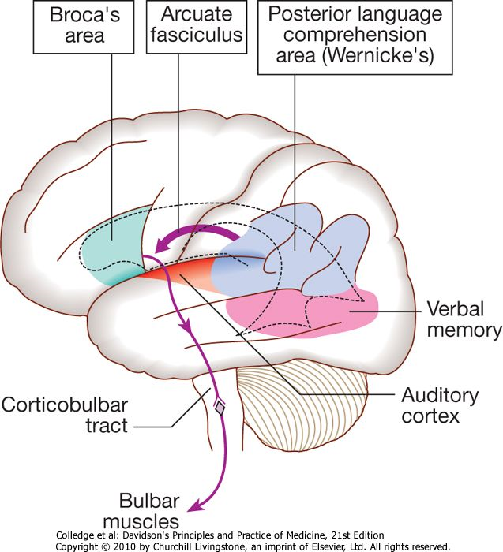

|  |
| --- |
|  |

|  |
| --- |
| * Speech is the process whereby vocal sounds are used to convey meaning between individuals. * A large volume of the cerebral cortex is involved in this complex process, mostly in the dominant hemisphere. * The decoding of speech sounds (phonemes) is a function of the upper part of the posterior temporal lobe. * The perception of these sounds as meaningful language, as well as the formulation of the language required for the expression of ideas and concepts, occurs predominantly in the lower parts of the anterior parietal lobe (the angular and supramarginal gyri). * The temporal speech comprehension region is referred to as Wernicke's area. * Other parts of the temporal lobe contribute to language processing in areas specialising in verbal memory, where lexicons of meaningful words are 'stored'. * Parts of the non-dominant parietal lobe appear to contribute to non-verbal aspects of language in the recognition of meaningful intonation patterns of spoken words (prosody). |

|  |
| --- |
| * The language information generated in the temporal and parietal lobes passes anteriorly via the arcuate fasciculus to Broca's area in the posterior end of the inferior frontal gyrus on the dominant side. * The motor commands generated in Broca's area then pass to the cranial nerve nuclei in the pons and medulla, as well as to the anterior horn cells in the spinal cord. * Nerve impulses then travel to the lips, tongue, palate, pharynx, larynx and respiratory muscles via the facial nerve and cranial nerves 9, 10 and 12, and result in the series of ordered sounds known as speech. * The cerebellum also plays an important role in coordinating speech, and lesions of the cerebellum lead to a speech disorder termed dysarthria. |

**The somatosensory system**

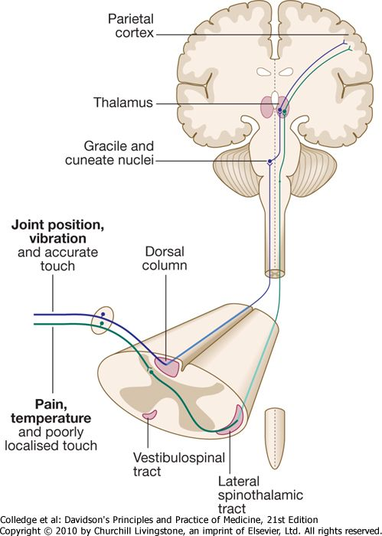

|  |
| --- |
| * Somatic sensory information from the limbs ascends the nervous system in two anatomically discrete systems. * Fibres from proprioceptive organs and those mediating well-localised touch (including vibration) enter the spinal cord at the posterior horn and pass without synapsing into the ipsilateral posterior columns. * Neural fibres conveying pain and temperature sensory information (nociceptive neurons) synapse with second-order neurons which cross the midline in the spinal cord before ascending in the contralateral anterolateral spinothalamic tract to the brain stem. |

|  |
| --- |
| * The second-order neurons of the dorsal column sensory system cross the midline in the upper medulla to ascend through the brain stem. Here they lie just medial to the (already crossed) spinothalamic pathway. Brain-stem lesions can therefore cause sensory loss affecting all modalities of the contralateral side of the body. * Sensory loss on the face due to brain-stem lesions is dependent upon the anatomy of the trigeminal fibres within the brain stem. Fibres from the back of the face (near the ears) descend within the brain stem to the upper part of the spinal cord before synapsing, the second-order neurons crossing the midline and then ascending with the spinothalamic fibres. * Fibres conveying sensation from progressively more forward areas of the face descend a shorter distance in the brain stem. Thus, sensory loss in the face from low brain-stem lesions is in a 'balaclava helmet' distribution, as the longer descending trigeminal fibres are affected. Both the dorsal column and spinothalamic tracts end in the thalamus, relaying from there to the parietal cortex. |

**Pain**

**The pain perception system.**

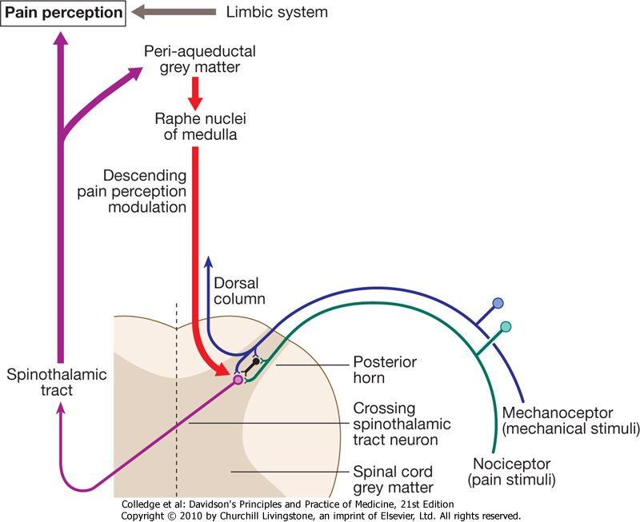

* Pain is a complex percept that is only partly related to activity in nociceptor neurons.
* In the posterior horn of the spinal cord, the second-order neuron of the spinothalamic tract is subject to modulation by a number of influences in addition to its synapse with the fibres from nociceptors.
* Branches from the larger mechanoceptor fibres destined for the posterior column also synapse with the second-order spinothalamic neurons and with interneurons of the grey matter of the posterior horn.
* The nociceptor neurons release neurotransmitters (such as substance P), in addition to excitatory transmitters, which influence the excitability of the spinothalamic neurons.
* Neurons in the posterior horn are also subject to modulation by fibres descending from the peri-aqueductal grey matter of the midbrain and raphe nuclei of the medulla.
* Neurons of this 'descending analgesia system' are activated by endogenous opiate (endorphin) peptides.
* The spinal cord's posterior horn is therefore much more than a way-station in the transmission of nociceptive sensory information; it is a complex organ for gating and modulating information about painful stimuli before this ascends in the spinothalamic tract.
* In the diencephalon the perception of pain is further influenced by the rich interconnections of the thalamus with the limbic system.

**SPINAL CORD**

* Lies within the vertebral canal.
* It extends from the atlas to lower border of L1
* It is surrounded by the dura, arachnoids and pia matter.
* CSF is found in subarachnoid space.
* LP is done below the level of L2 usually between L3-L4, because the SC is not there.
* Nerves conveying impulses from the brain to various organs descent via the SC.
* At appropriate levels they leave the SC to supply respective parts of the body.
* Similarly sensory nerves from body organs reach the brain by entering the spinal cord at various levels.

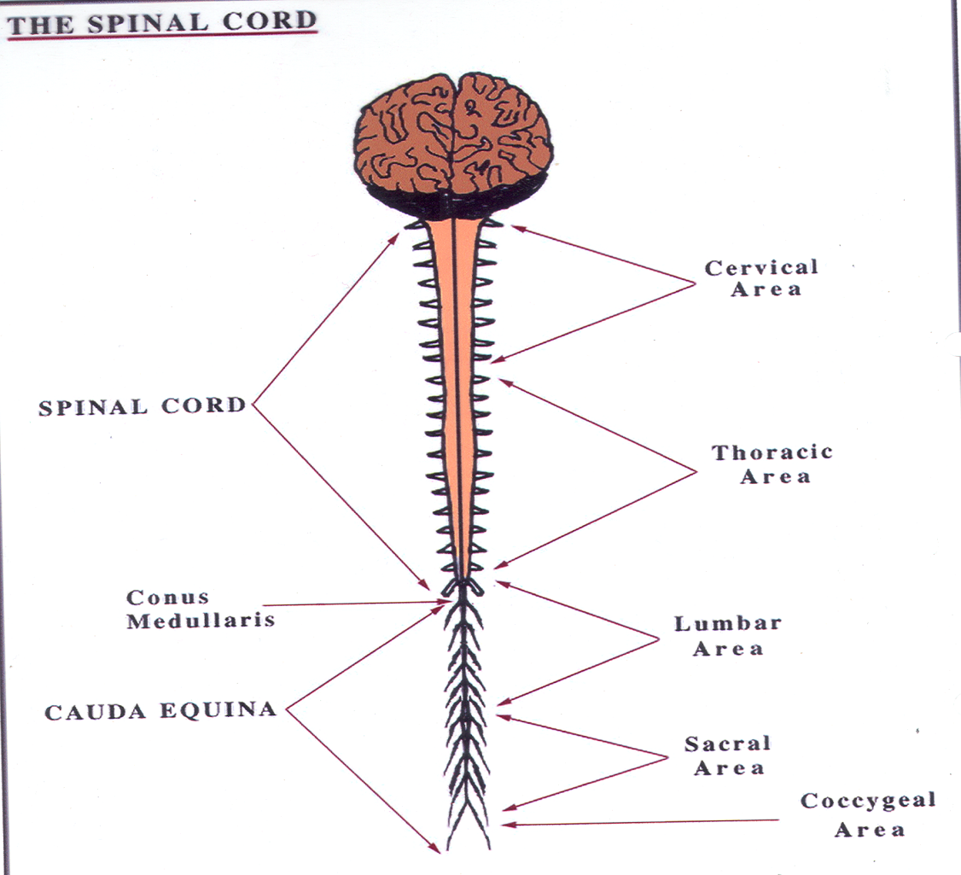

**MENINGES**

* The brain and spinal cord are covered by three membranes i.e. meninges,
* Named from without

1. Dura matter
2. Arachnoids matter
3. Pia matter

* Between the dura and arachnoids matter there is *subdural space.*
* Between the arachnoid and the pia matter is the *subarachnoid space.*
* Subarachnoid space contains CSF*.*

**Cerebral Spinal Fluid**

[**https://youtu.be/kaOphkMv2pM**](https://youtu.be/kaOphkMv2pM)

[**https://youtu.be/_aCCsRCw78g**](https://youtu.be/_aCCsRCw78g)

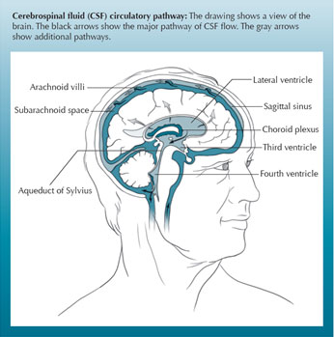

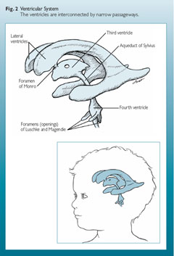

* It is produced by choroids plexus found in the walls of the lateral ventricles. It is secreted into the lateral ventricles.
* From here it is poured into the 3rd ventricles via the foramen of monro.
* It then flows into the 4th ventricle via the aqueduct of sylvius.
* From the 4th ventricle it flows out into the spinal cord via foramen magendie and lushka.
* It is then reabsorbed into the subarachnoid space and subsequently the brain and spinal cord.
* The CSF is reabsorbed into blood capillaries in the subarachnoid matter thus it gets into the blood stream.

**NB**

* The walls of the capillaries in the brain are less permeable than other capillaries in the body.
* This means that some substances are unable to cross their wall into the brain unless it is actively transported.
* Because of this reason, the composition of the tissues fluid in the brain and CSF are different from tissue fluid elsewhere in the body. This difference in permeability is called BBB.

**Composition of CSF**

1. Appearance – Normal CSF is clear or colourless
2. PH – slightly alkaline
3. Lymphocytes – 0-5 cells/µl
4. Glucose 2.5-4.2 mmol/l
5. Sg – 1.005
6. Pressure – 60-150mm of CSF
7. Contents:-
   1. Water
   2. Mineral salts
   3. Small amount of protein – 0.1-0.4 g/l
   4. Small amount of urea, and electrolytes
8. Tests for Syphilis – Negative
9. Stained Deposits – No organisms
10. Culture – sterile

**Functions of CSF**

* Supports and protects delicate structures of the brain and SC.
* It maintains uniform pressure around this delicate structure.
* Acts as a cushion and shock absorber for brain and SC.
* Gives the brain and SC moist and there may be exchange of substance between the fluid and the Nerve cells.

Dysfunction of spinal cord is classified into four types:

A. Complete transection

B. Incomplete transection

C. Hemisection

D. Diseases of spinal cord.

READ MAKE NOTES ON THE FOLLOWING;

EFFECTS OF HEMISECTION OF SPINAL CORD BELOW THE LEVEL OF LESION

EFFECTS OF HEMISECTION OF SPINAL CORD AT THE LEVEL OF LESION

|  |
| --- |
| **Sleep** |

|  |
| --- |
| * The function of sleep is unknown but it appears to be necessary for the normal functioning of the brain. * Normal sleep is controlled by the reticular activating system in the upper brain stem and diencephalon. * During overnight sleep, a series of repeated cycles of electroencephalogram (EEG) patterns can be recorded. * As drowsiness occurs, alpha rhythm disappears and the EEG gradually becomes dominated by deepening slow-wave activity. * After 60-80 minutes this slow-wave pattern is replaced by a short spell of low-amplitude EEG background on which are superimposed rapid eye movements (REM). * After a few minutes of REM sleep, another slow-wave spell starts and the cycle repeats several times throughout the night. * The REM periods tend to become longer as the sleep period progresses. * Dreaming takes place mostly during REM sleep. This is accompanied by muscle relaxation, penile erection and loss of tendon reflexes. * REM sleep seems to be the most important part of the sleep cycle for refreshing cognitive processes. Deprivation of REM sleep causes tiredness, irritability and impaired judgement. |

**The Complains**

Disorders of the nervous system may present with a legion of complains of, which the important ones are discussed below: -

1. Disturbances of memory
2. Disturbances of mood
3. Loss of consciousness
4. Illusions, Delusions, hallucinations
5. Insomnia
6. Headache
7. Visual disturbance

* Inability to see
* Double vision

1. Giddiness and vertigo (feeling of loss of balance with the impression that the surroundings are whirling around)
2. Dizziness (subjective feeling of unsteadiness)
3. Tinnitus (a subjective awareness of noise in the absence of any external stimuli)
4. Deafness
5. Aural pain or discharge
6. Dysphagia (may be associated with bulbar or pseudobulbar palsy)
7. Weakness or paralysis of limbs
8. Tremors
9. Numbness, paraesthesia (pins and needles)
10. Loss of sensation
11. Disturbances of bladder and bowel function (frequency and incontinence are associated with bilateral upper motor neurone lesions; incontinence may follow unilateral cerebrovascular accident; dementia is associated with incontinence)

xxxxxxxxxxxxxxxxxx